10.2-2)
Worst case performance of RANDOMIZED-SELECT will result due to the worst case performance of RANDOMIZED-PARTITION. Given that we have to find the minimum element, the worst case performance of RANDOMIZED-PARTITION will result if each call to it results in a partitioning around the maximum element left so far (i.e the maximum element is always chosen as the pivot).

3 | 2 | 9 | 0 | 7 | 5 | 4 | 8 | 6 | 1

Partition with pivot = 9
3 | 2 | 1 | 0 | 7 | 5 | 4 | 8 | 6

pivot = 8
3 | 2 | 1 | 0 | 7 | 5 | 4 | 6

pivot = 7
3 | 2 | 1 | 0 | 6 | 5 | 4

pivot = 6
3 | 2 | 1 | 0 | 4 | 5

pivot = 5
3 | 2 | 1 | 0 | 4
pivot = 4
3 | 2 | 1 | 0

pivot = 3
2 | 1 | 0

pivot = 2
1 | 0

pivot = 1
0

This gives the minimum element.
The worst case running time of RANDOMIZED-SELECT is θ(n²). This can be obtained by solving the following recurrence: T(n) = O(n) + T(n –1)

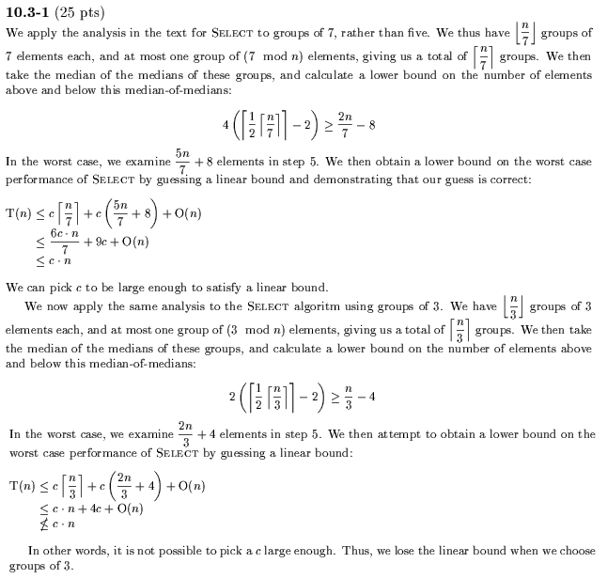

10.3-1)
For groups of 7, the algorithm still works in linear time. The number of elements greater than x
(similarly number less than x) is at least 4([1/2[n/7]- 2) ≥ 2n/7 –8
T(n) ≤ T([n/7]) + T(5n/7 +8) + O(n)
Which can be shown to be O(n) by substitution, as in the book.
For groups of 3, this no longer works in linear time. The recurrence becomes:
T(n) ≤ T([n/3]) + T(2n/3 +4) + O(n)
Which does not have a linear solution.
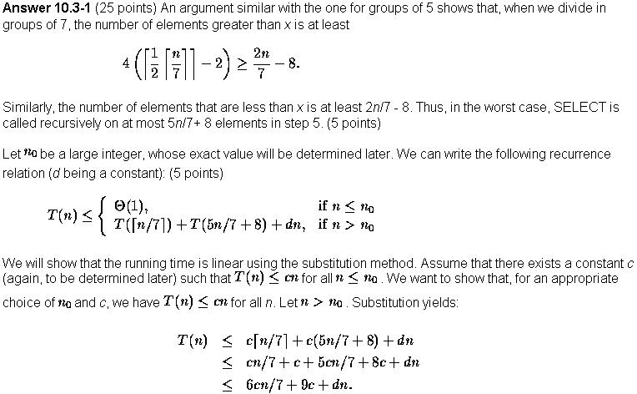
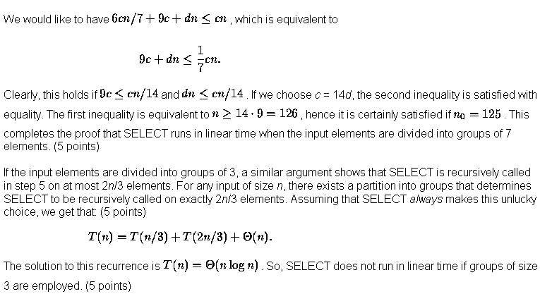

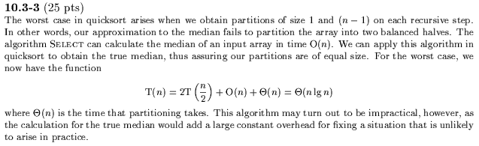
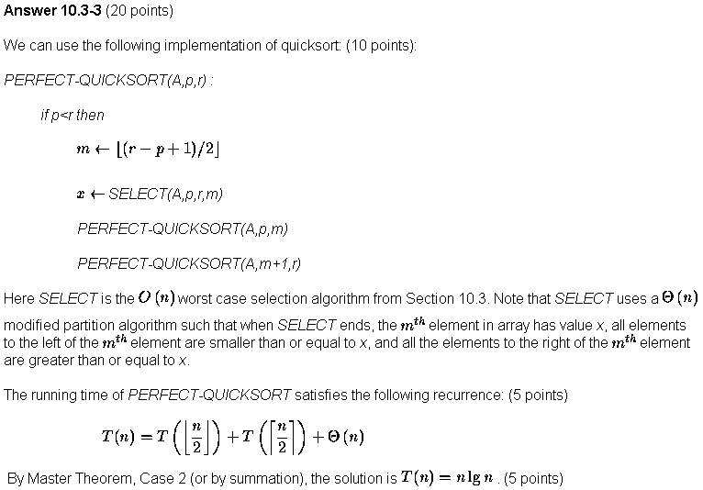

10.3-5)
Assume we can find the median in O(n) time, the algorithm is to find the median and then partition the array in to two using the median. Then we choose either partition based on whether the element we want to find is greater or smaller than the median. We then recurse on that particular subarray.
Time complexity, T(n)=T(n/2) + O(n) (for partition)
Which gives us T(n)=O(n).
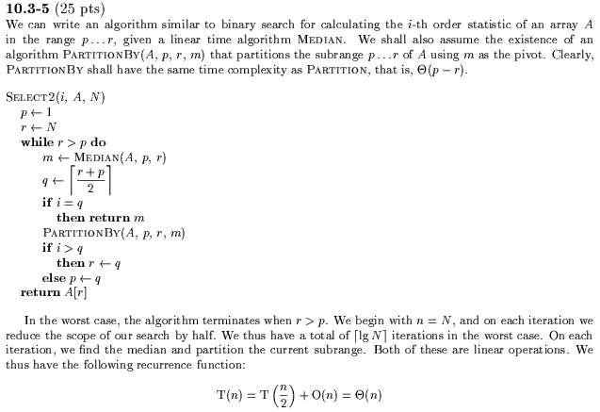

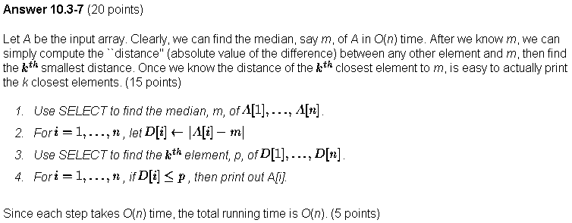

10.3-8)
Algorithm:
Let the two arrays be X and Y
Call Median2n(..) by Median2n(X,1,n,Y,1,n)

Median2n(X,x1,x,Y,y1,y2)
If x1>x2 or y1>y2, return X(x1)
u← (x1+x2)/2, v← (y1+y2)/2
If X(u) = Y(u), return X(u)
Else if X(u) < Y(u), return Median2n(X,u+1,x2,Y,y1,v-1)
Else return Median2n(X,x1,u-1,Y,v+1,y2)

Explanation:
At every recursion, we compare the medians of the two arrays, u and v.
If u<v, then we know that the overall median is greater than u and smaller than v, so we throw away elements less than u in the first array and greater than v in the second array.
If u>v, we know that the overall median is less than u and greater than v, so we throw away elements greater than u in the first array and less than v in the second array

Time complexity
T(n) = T(n/2) + O(1) or T(n) = O(lg n)

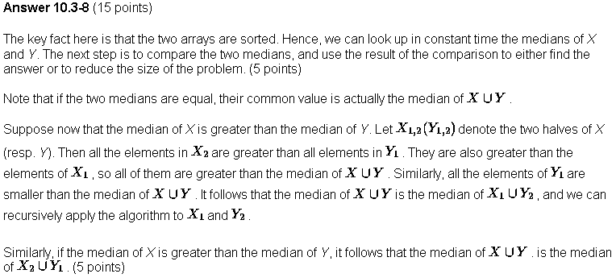
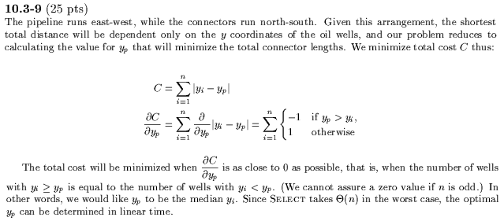

10-1)
a) We sort the n numbers using mergesort which take O(nlog n) worst case
time. Put the i largest elements from the sorted array into the output array, in O(i)
time. Therefore total worst case time = O(n log n) + O(i) = O(n log n).

c)To find the i_{th} largest number, we use the Select algorithm which takes O(n) time.
We partition the array of n numbers with this number, using the Partition algorithm which takes O(n) time. Finally we sort the i numbers after partitioning the array, using mergesort in O(i log i) time. So total time = O(n) +O(n) + O(i log i) = O(n) + O(i log i)

